**DAILY ONLINE ACTIVITIES SUMMARY**

|  |  |  |  |
| --- | --- | --- | --- |
| **Date:** | 12/07/2020 | **Name:** | Krishnitha |
| **Sem & Sec** | 4th sem, A Section | **USN:** | 4AL18CS039 |
| **Online Test Summary** | | | |
| **Subject** | NA | | |
| **Max. Marks** | NA | **Score** | NA |
| **Certification Course Summary** | | | |
| **Course** | User Engagement | | |
| **Certificate Provider** | Salesforce | **Duration:** | 3 hrs |
| **Coding Challenges** | | | |
| **Problem Statement:**  Program to count the subsets with sum equal to X using Recursion. | | | |
| **Status:** Executed | | | |
| **Uploaded the report in GitHub** | | YES | |
| **If yes Repository name** | | <https://github.com/krishnitha/C-coding> | |
| **Uploaded the report in slack** | | YES | |

**Certification Course Details:**

Today I started the new course “User Engagement” by Sales Force. Today I learnt about how to promote feature adoption and discovery and how to customize the troubleshooting. I have also successfully completed this course and have received a badge.

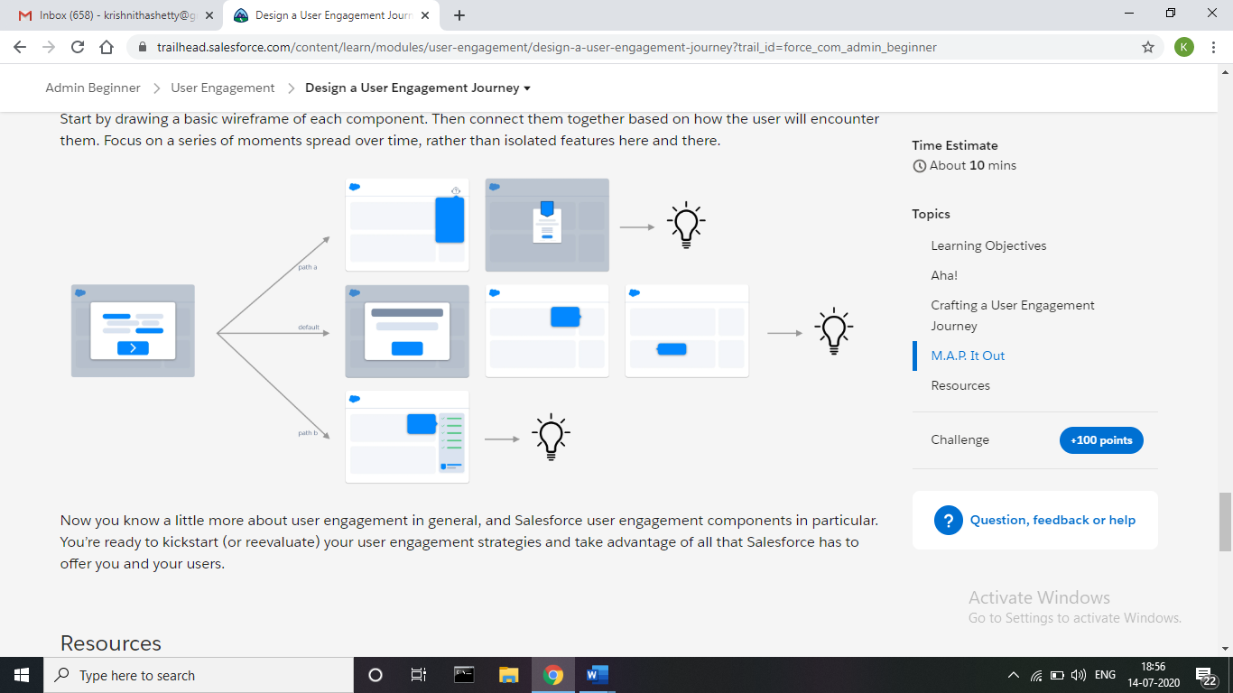



**Coding Challenges Details:**

**Problem:** Program to count the subsets with sum equal to X using Recursion.

Given an array arr[] of length N and an integer X, the task is to find the number of subsets with sum equal to X using recursion.

**Examples:**

Input: arr[] = {2, 3, 5, 6, 8, 10}, X = 10

Output: 3

Explanation:

All possible subsets with sum 10 are {2, 3, 5}, {2, 8}, {10}

Input: arr[] = {1, 2, 3, 4, 5}, X = 7

Output: 3

Explanation:

All possible subsets with sum 7 are {2, 5}, {3, 4}, {1, 2, 4}

**Solution:** Uploaded it in GitHub

